**AESO Market Price Data Preparation**

**Data Preparation Tool**

**Austyn Nagribianko**

**Supervisor: Hamid Zareipour**

**January 14, 2019**

Table of Contents

Project Introduction 1

Technical Specifications 1

Program Settings 1

Data Output 2

Event Data 2

Prepped Files 2

Instructions for Use 3

Suggestions for Continued Development 3

# Project Introduction

The motivation for this project was to develop a tool that reports the market price response and metrics to AESO grid events. The project aims to produce a tool for identifying potential areas of interest in forecasting the system marginal price (SMP) and pool price especially during price events (ie >$200 / MW).

# Technical Specifications

The program was developed in Python and utilizes a number of reporting files from NRGStream in order to produce the output files. The Input files are as follows:

* AESO Grid Events
* AESO SMPs ($ / MW)
* AESO Pool Prices ($ / MW)
* AB Total Electricity Demand (MW)
* AB Net Generation (MW)
* AB Total Intertie Power Exchange (MW)
* AB-BC Intertie Exchange (MW)
* AB-MT Intertie Exchange (MW)
* AB-SK Intertie Exchange (MW)

The program begins by filtering each event message and classifying the event type. The events are classified in two metrics: event type, and event asset. Event types have further been categorized into five types: offline, online, maintenance, frequency deviation, and outage. A majority of AESO grid events fall under the first two categories, referring to generators or other assets going online or offline.

The program has two output functions. The first produces an event database spreadsheet containing information and calculations regarding each grid event. Some of the useful information contained in the file includes the event date and time, event SMP and pool price, a flag for pool price and SMP events (Ie >$200 / MW), the max SMP and pool prices within a customizable range, as well as intertie and demand information for the specific event. The second function produces individual CSV files for each event. Each file is uniquely named and contains only the date and SMP over the customizable range.

## Program Settings

The program has several custom features that produce the resulting output files. Filters for events and assets can be changed to produce only the files containing the filtered information. The range of each prepped file as well as the range over which the metrics are reported can be set as well. In the instance seen in Figure 1, the range backwards and forwards for the pool price and SMP is set to 3 hours each way. The range backwards is only reflected in the prepped data files however the event database determines its reporting on the range after the event (ie if the range is three hours forward, a price spike 4 hours after won’t be acknowledged). The last variable, *measToFile*, gives the user the ability to write some of the event characteristics to each prepped data file however the same information is also reflected in the event database.

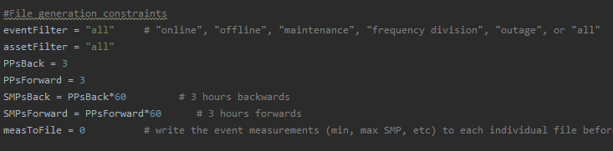

Figure AESO Market Price Data Prep Settings

The program has a single working directory which is the only setting that may need to be changed upon running the program on a different user’s workstation. All input and output directories are seen in Figure 2.

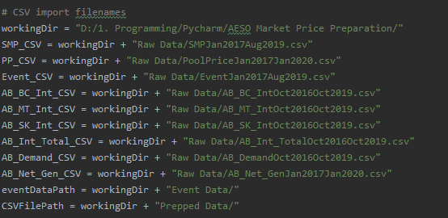

Figure File Directories

# Data Output

## Event Data

The event database file is saved to “…/Event Data”. The resulting CSV file reports event specific information and includes a number of grid condition metrics during the event occurrence. Potentially useful information includes price event flags for SMP and pool prices (>$200 / MW), the maximum and minimum SMP following the event SMP as well as the duration (in minutes) between the event and the maximum, Alberta generation and load conditions, as well as intertie conditions.

## Prepped Files

For each of the events in the event database, a separate file containing the event’s dates, and SMPs (over the user defined range, see Figure 1). Each file is uniquely named and was meant as a preparation for additional studying for use in neural network or machine learning analysis. Some event database measurements can be written to the prepped files by setting *measToFile* to 1 (see Figure 1).

# Instructions for Use

1. Ensure all appropriate libraries are installed in your Python environment and your environment runs properly prior to running the program
2. Change any of the directories in directory section to accommodate your machine
   1. You will need to change *workingDir* to match the working directory path of your program
   2. Other directories are of the preference of the user and do not necessarily need to be changed unless you are using different file names or file directories
3. Change any program settings including writing the measurements to the prepped files, or setting the reporting range for either the SMP or the pool price
4. Ensure all appropriate files are located in the correct directory before running
   1. The program requires 9 files to report all appropriate information (taken from NRGStream)
      1. AESO Grid Events
      2. AESO SMP ($ / MW)
      3. AESO Pool Prices ($ / MW)
      4. AESO Total Electricity Demand (MW)
      5. AESO Net Generation (MW)
      6. AESO Total Intertie Exchange (MW)
      7. AB-BC Intertie Exchange (MW)
      8. AB-MT Intertie Exchange (MW)
      9. AB-SK Intertie Exchange (MW)
   2. The program is limited at the AESO Grid Events file meaning that the program will only report as many files as there are events in the file
   3. Every other file must have a date range equal or greater than that of the AESO Grid Events file
   4. The program accounts for the header lines at the top of each NRGStream report however it does not account for any third columns (present in SMP and pool price files)
5. Ensure all output files are closed before running (the program will return an error if it cannot open and write to a file that is already open on the computer)
6. Run the program
   1. The program takes ~30 minutes to run on a laptop for a range of January 2017 to August 2019

# Suggestions for Continued Development

The program has the potential to include a number of additional metrics for studying the impact of grid events. Additional files can be included in the event report by following the comments in the file. These have been denoted with ADDITIONAL FILE as to instruct when to add additional code to accommodate the importing of another file.

The natural language processing that filters out the asset names and event types are accurate but not perfect. Continued development to further generate accurate filtering of these metrics will increase reportability of grid events.Additional program development is encouraged and will hopefully continue to increase the reporting capabilities of the program.